Assignment 4 Writeup – Skeletal Animation and Skinning

Part 1: Skeletal Animation

For this part, I literally just used the algorithm in the slides. That is, for each joint j: $F\left(j\right)=F\left(p\left(j\right)\right)R\left(j\right)T(j)$. This is possible, as said in the slides, because the array of joints is topologically sorted, so the parent transformation will always be computed before the child transformation. In the function, F is ‘p_globals’, T is ‘p_local’ and R is ‘p_offset’. Put that into code and you get my solution.

It seems to work visually. Here are some screenshots of the capsule and the ogre both in rest pose and animated pose.

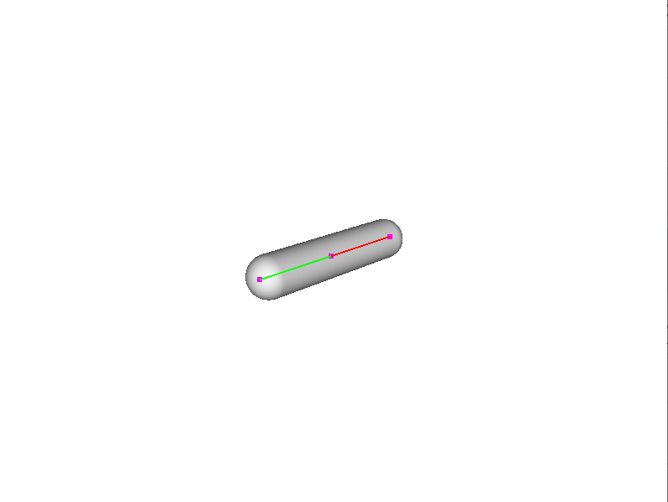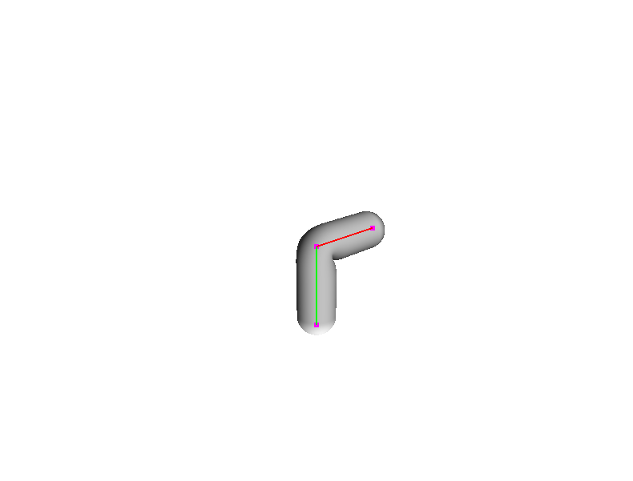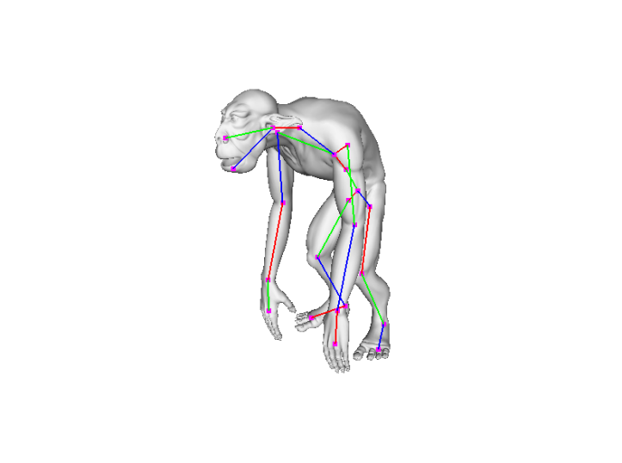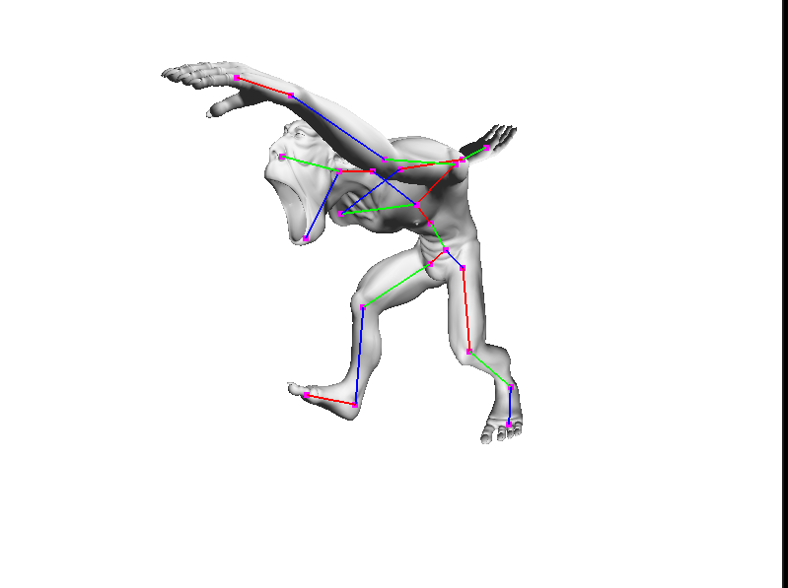

Part 2: Skinning

To complete this part, I just used the algorithm laid out in the slides as well. This one was more complicated to complement -- more loops involved. Some freedoms I took were:

* I accumulate the partial sum of the new vertex (v’) in a local variable, then copy it to the set of new vertices once the complete sum is calculated – once the inner loop is done. I figure this saves some time by avoiding converting each partial sum from homogenous coordinates before storing it, then converting it back to homogenous coordinates to compute the next partial sum. It also is more readable in my opinion.

It seems to work fine, the screenshots above also show that the skins for the capsule and ogre both follow the skeleton when its animated.